**JAC444 - Lecture 1**

Introduction to

Java Programming Language

Segment 4

**Overview of the Java Language**

**In this segment you will be learning about:**

* Numeric Operators in Java
* Type Conversion
* If, For, While, Do-While Statements
* Labeled Break and Labeled Continue
* Arrays and Strings

**Numeric operators in Java**

|  |  |  |  |
| --- | --- | --- | --- |
| Prec | Operator | Description | *Example* |
| **1** | **++** | **Increment by 1(or 1.0)** | *k++* |
| **1** | **--** | **Decrement by 1(or 1.0)** | *k--* |
| **1** | **+** | **Unary plus** | *+value* |
| **1** | **-** | **Unary minus** | *-value* |
| **2** | **\*** | **Multiplication** | *x * y* |
| **2** | **/** | **Division** | *x / y* |
| **2** | **%** | **Modulo** | *x % y* |
| **3** | **+** | **Addition** | *x + y* |
| **3** | **-** | **Subtraction** | *x - y* |
| **5** | **<** | **Less than** | *x < y* |
| **5** | **>** | **Greater than** | *x > y* |
| **5** | **<=** | **Less than/equal** | *x <= y* |
| **5** | **>=** | **Greater than/equal** | *x >= y* |
| **6** | **==** | **Equals (identical values)** | *x == y* |
| **6** | **!=** | **Is not equal to** | *x != y* |
| **13** | **op=** | **op assignment(+ =, - =, *=, etc)** | *x += y* |

**Bitwise and logical operators**

|  |  |  |  |  |
| --- | --- | --- | --- | --- |
| Pre | Operator | Type | Description | *Example* |
| 1 | **~** | Integral | Unary bitwise complement | ***~x*** |
| 1 | **!** | Logical | Unary logical complement | ***!b*** |
| 4 | **<<** | Integral | Left shift | ***x << 2*** |
| 4 | **>>** | Integral | Right shift (keep sign) | ***x >> 5*** |
| 4 | **>>>** | Integral | Right shift (zero fill) | ***x >>> 3*** |
| 5 | **instanceof** | Obj type | Tests class membership | ***o instanceof X*** |
| 6 | **==** | Object | Equals (same object) | ***x == y*** |
| 6 | **!=** | Object | Unequal (different object) | ***x != y*** |
| 7 | **&** | Integral | Bitwise AND | ***x & y*** |
| 7 | **&** | Logical | Logical AND | ***b1 & b2*** |
| 8 | **^** | Integral | Bitwise XOR | ***x ^ y*** |
| 8 | **^** | Logical | Logical XOR | ***b1 ^ b2*** |
| 9 | **|** | Integral | Bitwise OR | ***x | y*** |
| 9 | **|** | Logical | Logical OR | ***b1 | b2*** |

**Bitwise and logical operators**

|  |  |  |  |  |
| --- | --- | --- | --- | --- |
| Prec | Operator | Type | Description | *Examp.* |
| 10 | **&&** | Logical | Logical AND (short-circuit) | ***b1 && b2*** |
| 11 | **||** | Logical | Logical OR (short-circuit) | ***b1 || b2*** |
| 12 | **?:** | Logical | Conditional (ternary) | ***b ? x : y*** |
| 13 | **=** | Variable,any | Assignment | ***x = 1*** |
| 13 | **<<=** | Binary | Left shift with assignment | ***x <<= 2*** |
| 13 | **>>=** | Binary | Right shift with assignment | ***x =>> 3*** |
| 13 | **>>>=** | Binary | Right shift, zero fill, assign | ***x =>> 4*** |
| 13 | **&=** | Binary | Bitwise AND with assign | ***x &= y*** |
| 13 | **&=** | Logical | Logical AND with assign | ***b1 &=b2*** |
| 13 | **|=** | Binary | Bitwise OR with assignment | ***x |= y*** |
| 13 | **|=** | Logical | Logical OR with assignment | ***b1 |=b2*** |
| 13 | **^=** | Binary | Bitwise XOR with assignment | ***x ^= y*** |
| 13 | **^=** | Logical | Logical XOR with assignment | ***b1 ^=b2*** |

**Bitwise logic rules**

|  |  |  |
| --- | --- | --- |
| AND | 0 | 1 |
| 0 | 0 | 0 |
| 1 | 0 | 1 |

* + 1. & 0 = 0 0 & 1 = 0
    2. & 0 = 0 1 & 1 = 1

|  |  |  |
| --- | --- | --- |
| OR | 0 | 1 |
| 0 | 0 | 1 |
| 1 | 1 | 1 |

* + 1. | 0 = 0 0 | 1 = 1
    2. | 0 = 1 1 | 1 = 1

|  |  |  |
| --- | --- | --- |
| XOR | 0 | 1 |
| 0 | 0 | 1 |
| 1 | 1 | 0 |

* + 1. ^ 0 = 0 0 ^ 1 = 1
    2. ^ 0 = 1 1 ^ 1 = 0

**Bitwise operations on short**

**primitives (16 bit integers)**

Binary

Operation

Decimal

Hex

**0000 0000 0101 0100**

**op1**

**84**

**0x0054**

**0000 0001 0100 0111**

**op2**

**327**

**0x0147**

**0000 0000 0100 0100**

**op1 & op2**

**68**

**0x0044**

**0000 0001 0101 0111**

**op1 | op2**

**343**

**0x0157**

**0000 0001 0001 0011**

**op1 ^ op2**

**275**

**0x0113**

**1111 1110 1011 1000**

**~op2**

**-328**

**0**

**xFEB**

**8**

**Results of some bit-shifting**

|  |
| --- |
| 0000 0000 0000 0000 0000 0000 0110 0011 starting a = 99  0 0 0 0 0 0 6 3 a = 0x00000063 |
| 0000 0000 0000 0000 0000 0011 0001 1000 after a << 3 (792)  0 0 0 0 0 3 1 8 a = 0x00000318 |
| 0000 0000 0000 0000 0000 0000 0001 1000 after a >> 2 (24)  0 0 0 0 0 0 1 8 a = 0x00000018 |
| 1111 1111 1111 1111 1111 1111 1001 1101 stating b = -99  F F F F F F 9 D b = 0xFFFFFF9D |
| 1111 1111 1111 1111 1111 1111 1111 1001 after b >> 4 = -7  F F F F F F F 9 b = 0xFFFFFFF9 |
| 0000 0000 0000 1111 1111 1111 1111 1111 after b >>> 12 = 1048575  0 0 0 F F F F F b = 0x000FFFFF |

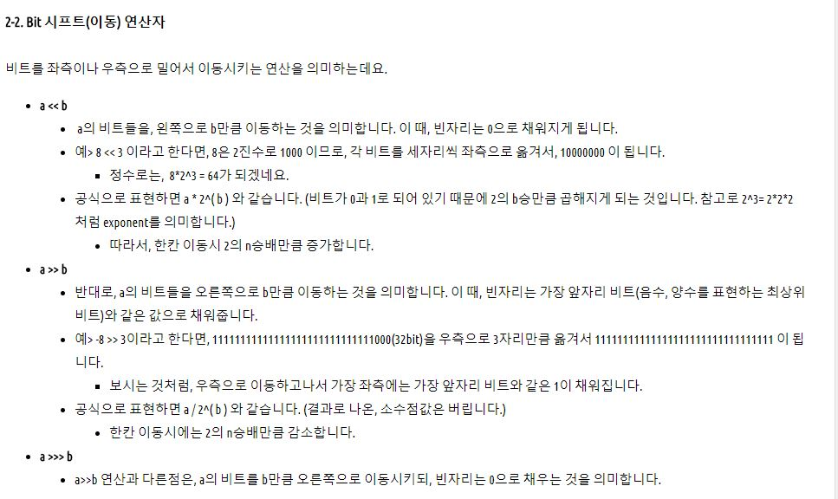 [**http://developer88.tistory.com/85**](http://developer88.tistory.com/85)

**Type Conversions**

* Java is a strong typed language
* Implicit conversion for primitive value: *any numeric value can be assigned to any numeric value whose type supports a larger range of values.*  ***byte → short → int → long → float → double***
* Explicit conversion – casting.
* *boolean* type doesn’t allow any casting at all.
* A *char* can be cast to any integer type and vice versa excepting to a short type. When *chart* is cast to *int* type upper bits are filled with zeros.
* Attention: interger types are converted by chopping off the upper bits.

If the larger integer has a value outside the range off the smaller type, dropping the upper bits changes the value, including possibly changing sign. ***Ex: short x = -129; byte y = (byte)x;*** *What is the value of y ???*

***if, if-else, if else –if else***

* 1. ***if (boolean-expression) { statements;***

***}***

* 1. ***if (boolean-expression) { statements;***

***} else { statements;***

***}***

* 1. ***if (boolean-expression) { statements;***

***} else if (boolean-expresion ) { statements;***

***} else {***

***statements;***

***}***

***for* Statement**

* A for statement should have the following form:

***for (initialization; condition; update) { statements;***

***} for (k = 0, flag; k < 10 && flag; k++ ) {***

***. . .***

***}***

Enhanced for loop ***for (variable : Collection ) {***

***. . .***

***}***

***while, do - while* Statements**

* ***while, do-while*** and for control looping are classified as *iteration statements.*

***while (condition) { statements;***

***}***

***do { statements;***

***} while (condition);***

**break - Labeled break**

* A break “drops out of the bottom” of the loop. The break statement with no label attempts to transfer control to the innermost enclosing ***switch****,* ***for, while*** or ***do-while*** of immediately enclosing statement.
* A labeled break drops out of the bottom of the end of the loop denoted by the label. *Ex:*

***out: for (int i = 0; i < 10; i++ ) { for (int k = 0; k < 10; k++) { if (i == k) break out;***

***}***

***System.out.println(i);***

***}***

**continue – Labeled continue**

* A plain continue goes to the top of the innermost loop and continues

* A labeled continue goes to the label and re-enters the loop right after that label

Ex: Calculates the factorials of odd number

***outerLoop: for (int i = 0; i < limit; i++ ) { for (int k = 2; k < i; k++) { if (i % 2)***

***continue outerLoop; factory *= i;***

***}***

***}***

**switch**

* The switch is classified as a *selection statement*

***switch (integral-selector) { case integral-value1:***

***statements; break; default:***

***statements;***

***}***

Integral-selector is an expression that produces an integral value.

The switch compares the result of integral-selector to each integral-value. If it finds a match, the corresponding statement (simple or compound) executes. If no match occurs, the default statement executes.

**Array**

* An array is simply a sequence of either objects or primitives, all the same type and accessed together under one identifier name.
* Arrays are implicit extensions of *Object.*
* Arrays are defined and used with square-brackets *indexing operator* [ ]

***int[] integerArray = new int[3];***

* A Java array is guaranteed to be initialized and cannot be accessed outside of its range.

***for (int k = 0; k < integerArray.length; k++) integerArray[k] = k;***

* Creating an array of objects, one is really creating an array of references, and each of those references is automatically initialized to null. ***Student[] room = new Student[3];***

**Strings**

* Java strings are standard objects with built-in language support.
* The String class represents character strings. All string literals in Java programs, such as "abc", are implemented as instances of String class
* Strings are constant; their values cannot be changed after they are created. Stringbuffer class supports mutable strings. Because String

objects are immutable they can be shared ***String str = "abc";***  is equivalent to:

***char data[] = {'a', 'b', 'c'}; String str = new String(data);***

**String Examples**

Here are some more examples of how strings can be used:

***System.out.println("abc");***

***String cde = "cde";***

***System.out.println("abc" + cde);***

***String c = "abc".substring(2,3);***

***String d = cde.substring(1, 2);***

***int length();*** returns the length of this string.

***char charAt(int index);*** returns the character at the specified index.

**Conclusions**

**After completion of this lesson you should know:**

* How to write a simple Java Program
* How to work with primitives: integers and floats
* To use Java tools like: compiler and interpreter

